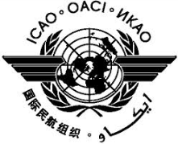 | International Civil Aviation Organization  Sixth Meeting of the Asia Pacific Regional Aviation Safety Team (APRAST/6)  (Bangkok, Thailand, 6 – 10 April 2015)

Agenda Item X: | Xx

TITLE

(Presented by State/Organization)

SUMMARY

Text.

1. INTRODUCTION

1.1 Text.

1.2 Text.

2. DISCUSSION

2.1 Text.

2.2 Text.

3. ACTION BY THE MEETING

3.1 The Meeting is invited to:

- text;
- text; and
- text.

— END —

